**ANSWER KEY SUBMISSION**

|  |  |  |  |
| --- | --- | --- | --- |
| **Date of Exam & Session** | **23.2.2023/AN** | **Category of Exam** | **CLA1** |
| **Course Name** | **FIBER OPTICS AND OPTOELECTRONICS** | **Course Code** | **18ECO107T** |
| **Name of the Faculty submitting** | **A.ALICE LINSIE,AP** | **Date of submission of Answer Key** | **24.2.2023** |
| **Department to which the Faculty belongs to** | **ECE** | **Total Marks** | **25** |

**PART-A (5x1= 5)**

1. a)222 THz
2. d)2.4
3. d)14o
4. a)1/√µoεo
5. a)Lumens

**PART B (2x4= 8)**

1. **a) A step-index silica fiber with a core radius much longer than the operating wavelength of light has a core refractive index of 1.50 and a cladding refractive index of 1.48. Calculate the acceptance angle in water having a refractive index of 1.33.**

ncore(n1) = 1.50 , 

ncladding(n2)=1.48, nwater(no)=1.33 **………………..(1mark)**

so, NA=0.1836 & Acceptance angle =Ɵa=Sin-1(NA)=10.579o**………………..(1mark)**

**b) Differentiate between Single and Multi-mode fiber.**

**Characteristics of Multi-Mode:**  
- Larger core diameter, usually 50 – 100 Micrometers, (62.5 most common)  
- Widely used cable in LAN networks today  
- Easier to terminate  
- Transmitters and receivers are more economical  
- Used at shorter distances **………………..(1mark)**

**Characteristics of Single-Mode:**- Small core diameter, 8 to 12 microns  
- Widely used cable in WAN networks today  
- More difficult and costly to terminate  
- Transmitters and receivers are more expensive  
- Typically used over long distances **………………..(1mark)**

**7.Using Snell’s law define the relationship at interface between two different media.**

Snell's law (also known as Snell–Descartes law and the law of refraction) is a [formula](https://en.wikipedia.org/wiki/Mathematical_formula) used to describe the relationship between the angle of incidence and refraction and refraction, when referring to light or other waves passing through a boundary between two different isotropic media, such as water, glass, or air.

Snell's law states that the ratio of the [sines](https://en.wikipedia.org/wiki/Sine) of the angles of incidence and refraction is equivalent to the ratio of [phase velocities](https://en.wikipedia.org/wiki/Phase_velocity) in the two media, or equivalent to the reciprocal of the ratio of the [indices of refraction](https://en.wikipedia.org/wiki/Refractive_index): **…………………………………(2marks)**{\displaystyle {\frac {\sin \theta _{2}}{\sin \theta _{1}}}={\frac {v_{2}}{v_{1}}}={\frac {n_{1}}{n_{2}}}}

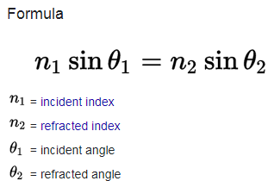**…………………………………(2marks)**

**PART C (1x12= 12)**

**8.a)Infer in detail about various elements of optical fiber transmission link with necessary diagrams.**

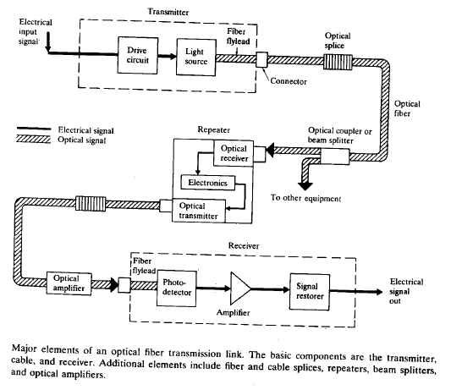

**…………………(4marks)**

**Key sections:(each section explanation )……………….(2marks each)**

**Transmitter**-Consists of light source and its associated drive circuitry

**Cable**-offering mechanical and environmental protection to optical fibers inside

**Receiver**-consists of photodetector plus amplification and signal-restoring circuitry.

**Additional components:** optical connectors,splices,couplers or beam splitters and repeaters

Optical fiber is one of the most important elements in optical fiber link

Installation can be done either aerial,in ducts,undersea, or buried directly in the ground.

**Length:** several hundred meters to several km for long-distance pplications

1. **b)Elaborate about ray optics and types of rays with necessary representation.**

* Optics is the study of light and its interaction with matter. Light is visible electromagnetic radiation, which transports energy and momentum (linear and angular) from source to detector.
* Photonics includes the generation, transmission, modulation,amplification,frequency conversion and detection of light.
* Ray optics is the simplest theory of light.
* Rays travel in optical media according to a set of geometrical rules; hence ray optics is also called geometrical optics.
* Ray optics is an approximate theory, but describes accurately a variety of phenomena.
* Ray optics is concerned with the locations and directions of light rays, which carry photons and light energy (They also carry momentum, but the direction of the momentum may be different from the ray direction). It is useful in describing image formation, the guiding of light, and energy transport………………..**(2 marks)**

**Postulates of Ray Optics**

1. Light travels in the form of rays (can think of rays as photon currents).Rays are emitted by light sources, and can be observed by light detectors.

2. An optical medium (through which rays propagate) is characterized by a real scalar quantity n ≥ 1, called the refractive index. The speed of light in vacuum is c = 3 × 108m/s.The speed of light in a medium is v = c/n; this is the definition of the refractive index. The time taken by light to cover a distance d is t = nd/c; it is proportional to nd, which is called the optical path length.

3. In an inhomogeneous medium, the refractive index n(r) varies with position; hence the optical path length OPL between two points A and B is

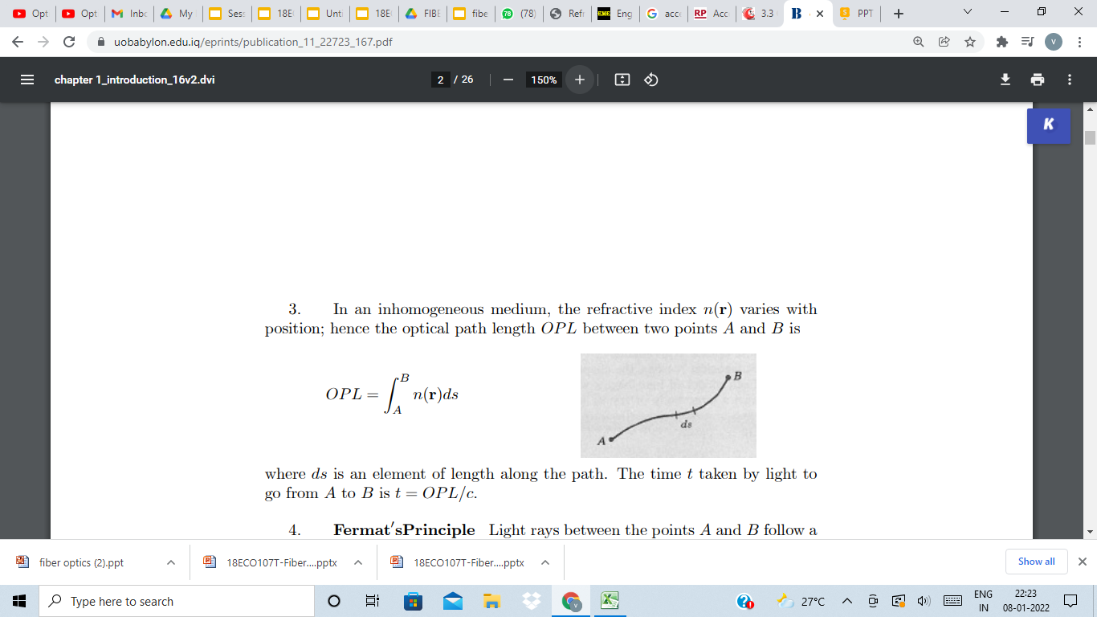

where ds is an element of length along the path. The time t taken by light to go from A to B is t = OPL/c .………………..**(2 marks)**

**Types of Rays**

**Rays that Interact with surfaces:**

* An incident ray is a ray of light that strikes a surface. The angle between this ray and the perpendicular or normal to the surface is the angle of incidence
* The reflected ray corresponding to a given incident ray, is the ray that represents the light reflected by the surface. The angle between the surface normal and the reflected ray is known as the angle of reflection. The Law of Reflection says that for a specular (non-scattering) surface, the angle of reflection is always equal to the angle of incidence.
* The refracted ray or transmitted ray corresponding to a given incident ray represents the light that is transmitted through the surface. The angle between this ray and the normal is known as the angle of refraction, and it is given by Snell's Law. Conservation of energy requires that the power in the incident ray must equal the sum of the power in the refracted ray, the power in the reflected ray, and any power absorbed at the surface
* If the material is birefringent, the refracted ray may split into ordinary and extraordinary rays, which experience different indexes of refraction when passing through the birefringent material.

**Optical systems**

* A meridional ray or tangential ray is a ray that is confined to the plane containing the system's optical axis and the object point from which the ray originated.
* A skew ray is a ray that does not propagate in a plane that contains both the object point and the optical axis. Such rays do not cross the optical axis anywhere, and are not parallel to it.
* The marginal ray (sometimes known as an a ray or a marginal axial ray) in an optical system is the meridional ray that starts at the point where the object crosses the optical axis, and touches the edge of the aperture stop of the system.

.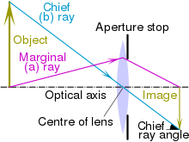**…………………………………………………….(6 marks)**

**Types of rays:**

The principal ray or chief ray (sometimes known as the b ray) in an optical system is the meridional ray that starts at the edge of the object, and passes through the center of the aperture stop

Sagittal ray or transverse ray

Paraxial ray

Parabasal ray **…………………………………..(2marks)**